Warm-ups For Colonization
1. Where would you rather live?
Where Would You Rather Live? | Your answer and explanation:
A. Good school system, citizens get to have a say in town situations, church is very important.  B. Everyone has an equal chance of doing well, although you are probably not going to get rich. There is much cultural diversity and neighbors work together to support community ideals.  C. You may have the opportunity to make a great fortune but is going to take some hard work. If you do make it, you get to be the one to make all decisions for the community. | Letter Choice: ______  Explanation:
----------------------------------------------------------------------------------------------------------------------------------------------------------------
2. Colonial Life Experiences
Read each statement and decide whether they are true or false: | True or false | If false, fix answer here
1. Farmers work very little and have a lot of free time.
2. People accused of crimes in the colonies are imprisoned without trial.
3. Criminals were rarely punished severely.
4. There is an equality of wealth among the colonists.
5. Colonial parents believed children should have plenty of play time and not work too hard.
6. Cooking is a full-time task.
7. Most colonial cities are built along waterways and have a variety of jobs.

----------------------------------------------------------------------------------------------------------------------------------------------------------------
3. Visual Discussion
Look at the picture and answer questions:
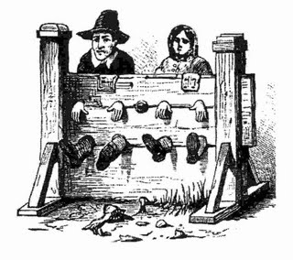 | 1. What is this a picture of?  2. Do you think this is an effective form of punishment? Why or why not?
4. Colonial Advertisements:

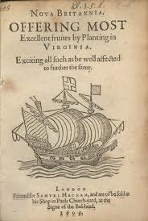
Questions for Colonial Ad:
1. What is the ad promising to those who come to Virginia?

2. What is the ad leaving out?

3. How would you change the ad to get more people to colonize?

