Unit One Vocabulary:
Unit 1 Term | Definition | Visual Aid
Bacon’s Rebellion

Columbian Exchange

Dissenters

Great Awakening

Headright System

Indentured Servants

Iroquois Constitution

Maryland Toleration Act

Mayflower Compact

Middle Passage

Pequot War

Plantation System

Powhatan War

Salem Witch Trials

Starving Time

Town Meetings

Triangular Trade

Unit 1 Biographies: Why are these people important?
Person | Impact on US History | Person | Impact on US History
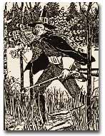 | William Bradford  Who:  Why: | 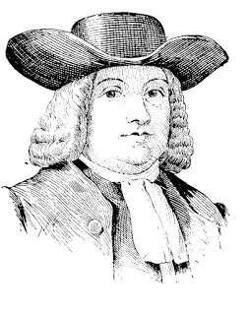 | William Penn  Who:  Why:
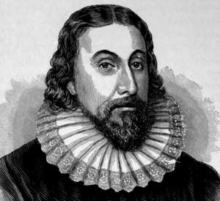 | John Winthrop  Who:  Why: | 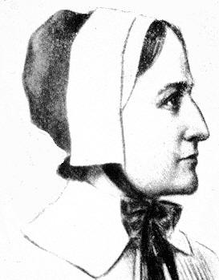 | Anne Hutchinson  Who:  Why:
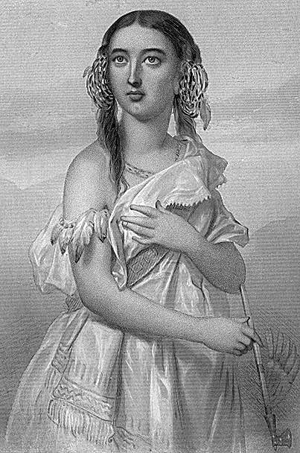 | Pocahontas  Who:  Why: | 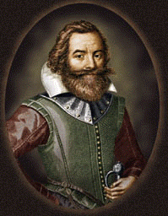 | John Rolf  Who:  Why:
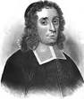 | Thomas Hooker  Who:  Why: | 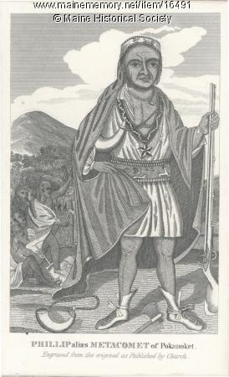 | Metacomet/Metacom  Who:  Why:

