Unit 6 Study Guide: The Civil War
Part 1: Slavery
According to the article “21st Century Slaves,” how do people become modern-day slaves? | How did 19th Century slavery affect families? | What is Frederick Douglass famous for?
What law makes the North responsible for slavery and ultimately helps lead to the Civil War? | In Harriet Jacob’s account of her life, why does she state that slave women had it harder than men? | According to Unchained Memories, what was the main reason given for why young slaves (children) were purchased?
Which novel increased the number of female abolitionists as the story talked about the horrors of slavery and the women were moved to do something about it? | Why didn’t many abolitionists get involved in the Underground Railroad? | How did the people involved in the Underground Railroad keep it secret?
What does this mean: The conductor is going to forward 2 parcels to the next station. Please let the stationmaster know that the parcels then need to be forwarded on to the promised land.

Part 2: Events that Lead to the Civil War
What happens in Kansas after the Kansas-Nebraska Act is passed? | 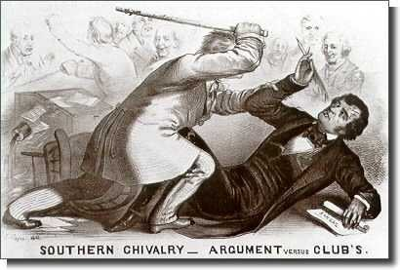 | In the picture, why did Brooks attack Sumner?
What happens to Brooks after this incident? | Why do Northerners dislike the outcome of the Dred Scott case? | Why are the Lincoln-Douglass debates considered a cause for the war?
Why did John Brown’s raid on the arsenal at Harper’s Ferry fail? | 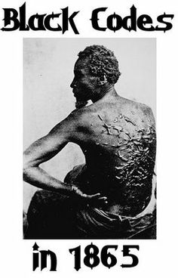  How is this image  used at this time? | Why do the Southern states secede after the Election of 1860 results are made public?
Part 3: Fighting the War
What are some of the strengths of the Union army? | What are some of the Confederacy’s weaknesses? | Who was better equipped to win the war? Why?
What was the name of the Union’s battle strategy? | 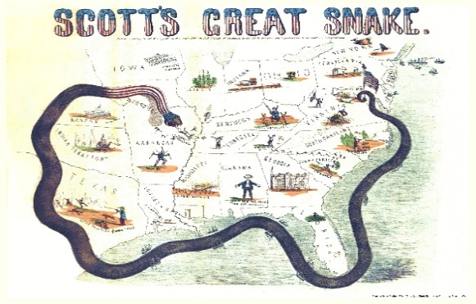 | What was the purpose of this strategy?
How does Lincoln use the railroad system for the war? | What is the main cause of death for soldiers during the war? | During the battle of Bull Run, ladies and gentlemen come out to watch the battle and have a picnic. They did not have a pleasant experience. What does their behavior suggest about their pre-conceived notions about the war?
Why is Gettysburg considered a turning point in the war? | Why was Vicksburg an important win for the north? | Why is Sherman’s March considered “Total War?”

Part 4: Reconstruction
How does Presidential Reconstruction differ from Radical Reconstruction? | What was the role of the Freedman’s Bureau? | Why was sharecropping still akin to slavery in the eyes of many?
What was the real reason behind Johnson’s impeachment (not really about Tenure of Office Act)? | Even though the Civil Rights Act of 1866 was passed, why did the Radical Republicans still feel the need to pass the 14th Amendment? | How did Southern whites get around the 15th Amendment to keep the African-Americans disenfranchised?
Who were the carpetbaggers? | Why did Reconstruction finally end? | How did the Compromise of 1877 settle the problems between the Democrats and Republicans?

