Unit 2 Midterm Review Questions
1.Which period of time in history gave us ideas such as natural rights, consent of the governed, republicanism, and the social contract? | 2. Baron de Montesquieu came up with a way to limit the power of government which the US eventually adopted. What was that idea? | 3. When Thomas Jefferson suggests that the government exists solely for the protection of people, what idea is he discussing?
4. When Thomas Jefferson writes about life, liberty, and the pursuit of happiness, who did he “borrow” the idea from? | 5. Who is associated with the idea below?  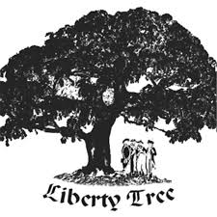 | 6. Which event will eventually lead to the American Revolution as salutary neglect ends and the British start to rule the colonies with new taxes and laws?
7. What role does Paul Revere play in the Revolution? | 8. Which laws passed by the government spurred the protest phrase “no taxation without representation?” | 9. What was the purpose of the Declaration of Independence?
10. “Volumes have been written on the subject of the struggle between England and America. Men of all ranks have embarked in the controversy, from different motives, and with various designs; but all have been ineffectual, and the period of debate is closed. Arms as the last resource decide the contest; the appeal was the choice of the King, and the Continent has accepted the challenge.”  According to this quote in Common Sense, who does Thomas Paine blame for the violence? | 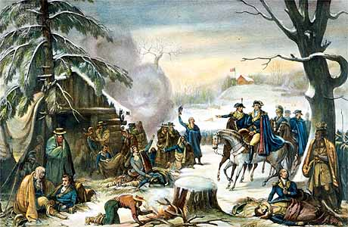  11. What does Valley Forge illustrate about the plight of the American soldier during the war? | 12. What makes George Washington an effective leader of the Continental Army? 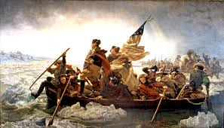
13. How are the Intolerable Acts and the Boston Tea Party related? | 14. What is the significance of the battle at Lexington and Concord? | 15. Francis Marion, otherwise known as the Swamp Fox, illustrates one of the advantages that the American army had over the British. What is it?
16. Why is the win at Saratoga so important for the Continental (American) Army? | 17. Why did the British army surrender at Yorktown? | 18. What is one reason why a person remained neutral in this battle?
19. What were two reasons the Patriots gave for their rebellion? | 20. What was a reason why someone may have been a Loyalist? | 21. Many African Americans who were Patriots became very frustrated after the American Revolution. What was the reason for this frustration?
22. When Abigail Adams states that women won’t be held accountable for laws they had no say in, what is she telling her husband that women want? | 23. The public school system in American begins to be set up during this period. What idea about our public school system comes from the colonial experience? | 24. Why did the Americans win the American Revolution? (Hint: what advantages did we have over the British?)

