Technology and Sectionalism:

What is Sectionalism?
Modern Day
Examples

Geographic and Economic Trends: How the North and South Differ
North | South
- Cannot ______________ on a large scale; must fish or trade for a living  - ________________ growing season for those who do farm  - Plenty of rivers and natural ports  - Vast forests  - Industrialization will lead to a ______________ system | - Specializes in ___________-scale farming  - _____________________ becomes an important cash crop (Cotton Kingdom)  - Moderate, warm climate  - ___________ growing season  - Plenty of rivers  - Agriculture leads to a _________________ system

Specific Technological Advances
Cotton Gin  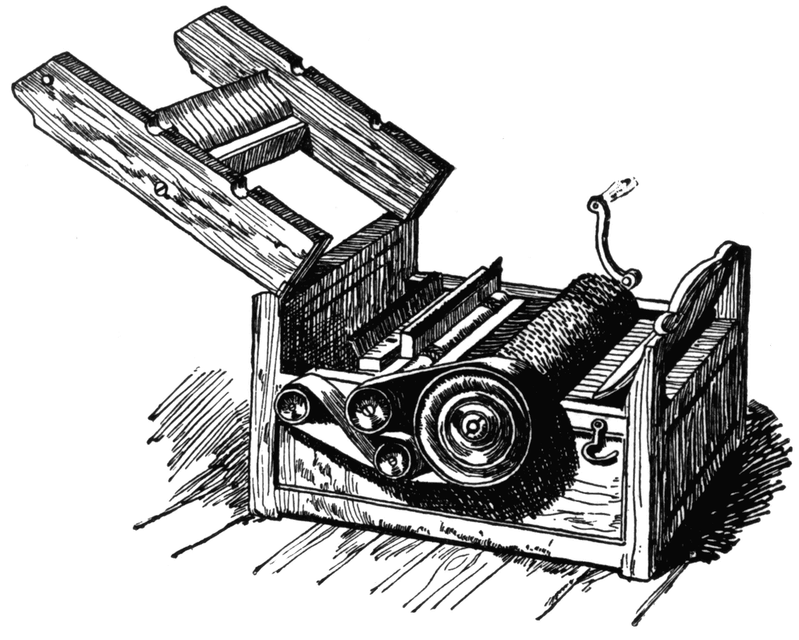 | Other agricultural advancements  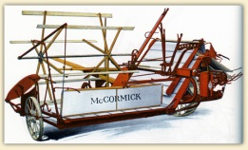  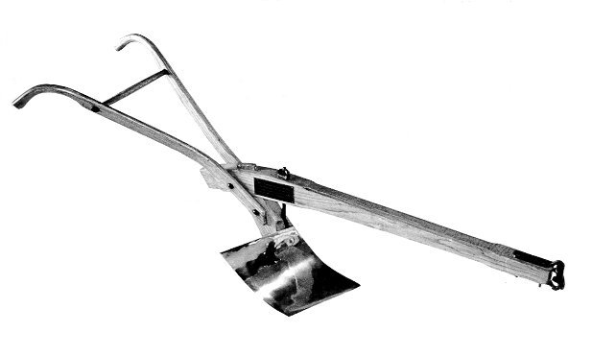  Steel Plow Cy McCormick’s Reaper
Textile Mill | 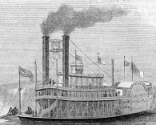  Transportation  Erie Canal Steam Boat
Communication – Telegraph | How do these lead to sectionalism?
Mini assessment: Create an advertisement to sell one of these technological advancements
Directions: On a separate piece of paper, create an ad for one of these advancements. Your ad must contain:
1. The name of the advancement
2. A catch phrase about it to get people’s attention
3. A description of what it is
4. A comparison of what their life was like before and after the advancement
5. And a visual
Ad must be neat, creative, and colorful
Category | 3 – High Quality/Close to perfect | 2 – Mediocre Quality | 1 Low Quality | 0 – Can’t Score it
Name of Advancement | N/A | Is it there? | N/A
Creative Catch phrase
Description
Comparison
Visual
Neat and Creative
Effort
Total: _________ 20=

