WELCOME TO
AMERICAN HISTORY 1
Where’s the rest of it? This year, you will complete the first in a new series of courses: American History 1 and American History 2. American 1 covers Exploration to Reconstruction (just after the Civil War). Next year you will finish the story.

Sign up for Ms. Wunderlich’s text notifications:

American 1
Send a text message to:
870-663-0813
With the message: @adayameri
Or
@bdayameri

Supplies Needed:
- PENCILS AND PENS!
- Colored pencils/markers

Grading:

- 30% performance
(homework/daily grades/quizzes)
- 70% assessment
(tests/projects/other – as announced)
Please note: Retakes and test corrections cannot be given any more credit than an 84%. If you want to do better, you must study!

How to Contact Ms. Wunderlich:
- Email: jaime.wunderlich@cms.k12.nc.us (the best way to contact me)
- Website: wunderlichsclassroom.weebly.com
- Tutorials: Thursdays and Fridays during enrichment. To get pulled, write your name on the board. Remember, this is not ”extra time” to take advantage of so you don’t have to pay attention in class. Only serious students will be invited to come.

Attendance and late work policy: Poor attendance is one of the main reasons for poor performance. Students can only miss 10 days of class. Anything over 10 can lead to automatic failure if the student does not complete recovery. Recovery will be discussed on a case by case basis. It is the student’s responsibility to come by and get the work and notes that they missed. To assist with due dates and absences, you will receive a weekly assignment sheet that has a listing of daily assignments and homework. You need to refer to this on a daily basis so that you are constantly aware of your academic expectations.

Assignments and projects that are late are not considered “make-up” work and will be docked credit. As projects are assigned in advance, they are due on the date specified. Computer glitches and ink problems are NOT acceptable excuses for late projects as they are given ahead of time.

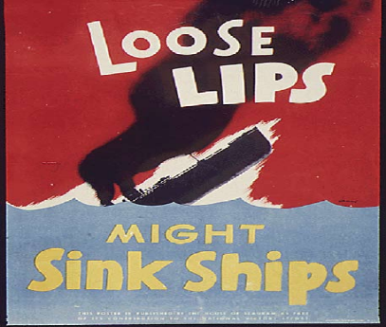

Rules

- Tardy bell – When the warning bell rings students will be in the classroom ready to work. Tardies will be handled according to the NMHS policy.
- If you fall asleep or put your head down I will usually wake you up the first time – consider this your warning. If you fall asleep a second time you will be subject to disciplinary action.
- Dismissal – No crowding the door or “bolting” out of the classroom until I say so. Please stay in your seat until I dismiss you.
- Talking & disruptive behavior – Any behavior that is disruptive to class will be dealt with. This covers talking while instruction is in progress, obscene or offensive language, profanity, and general disruptiveness.
- No food or drinks in the classroom
- School policy applies for cell phones and electronics.
- Students are expected to come to class prepared to learn and work. You should have all supplies each and every day.

Please fill out information below and return the next day to class.
Student Name: (Print) ID#

Parent/Guardian Name: (Print)

Parent/Guardian email:

Parent/Guardian Phone:

(Home) (Cell)

(Work)

Anything I should know about you/your child: (work, sports, medical information)

Parents/Guardians: Please sign below after reading over the syllabus with your child. Thank you – together we will all have a great year!

Parent/Guardian Signature:

______________________________________________________

