Speed Dating – Unit 1: Exploration and Settlement Vocabulary
Q# | Question | Answer
1 | Period in the Massachusetts Bay Colony where paranoid and self-serving colonists accuses their neighbors of making deals with the devil.
2 | His experiments with tobacco helped save Jamestown. His marriage to a young Indian woman kept peace between his groups and the local tribe, for a while.
3 | Atlantic trade system responsible for transporting world commercial products such as tobacco, rum, guns, and slaves.
4 | Responsible for European expansion in the New World as this group had issues with the Puritan laws so they left and started new colonies.
5 | Helped create the colony of Connecticut and responsible for creating the first colonial constitution known as the Fundamental Order of Connecticut.
6 | The reason why we have tomatoes on our pizza, sugar mixed with our chocolate, decreased Native populations, and kudzu.
7 | Used as an incentive to get colonists to populate Virginia as the leaders would promise those who moved there 50 acres of free land (100 if you were already there).
8 | His colonization method was to be open and honest and allow any who wanted to colonize there freedom and friendship.
9 | Proof that democracy existed before the Europeans came to North America, this unwritten agreement created a way for the 5 Nations to keep the peace and make agreements.
10 | Got fed up with the colonists constantly expanding onto land and destroying crops so he led one of the bloodiest wars between the colonists and the Natives.
11 | Colonists began to feel that the church was not reaching them so they would go to revivals in open fields where the ministers would give passionate sermons that would allow them to feel connected to God again.
12 | As a Puritan, she was devout but had a hard time following the rules of Massachusetts so she fled and helped found Rhode Island.
13 | Cramped spaces, chained movement, horrific conditions were some of the characteristics of this portion of a voyage that African slaves were forced into.
14 | She was known for being brave, kind, and beautiful but she also managed to bring a temporary peace between her people and new colonists to the land.
15 | A group of frontier colonists decides to rise up against their governor over disagreements about how to handle Native Americans. Considered an early spark of the Revolutionary Period.
16 | Created as a way to protect Catholics while enticing Protestants to colonize the area, it is seen as an early support for the first amendment’s free religion clause.
17 | Main population of the colonies in the early years as they came over in numbers to work a few years before gaining the freedom to live their lives on their own terms.
18 | Series of battles between Native Americans and colonists over the colonists expanding tobacco business into Indian territory.
19 | Strict governor of Massachusetts bay colony who wanted to create a “city on a hill” where everyone would look their colony as an example.
20 | Written as a promise to create order in the new colony, this document can be seen as an early promoter of democracy and self-government in colonial North America.
21 | In the winter of 1609-1610, most of the Jamestown colonists died due to an inability to use the land they had discovered properly to survive. Cannibalism ensues.

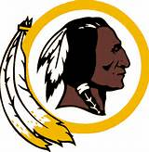  Based on what we learned  In this unit, what was the  Issue with this logo?  ----------------------------------------------------------------------------  How can we prove it? | 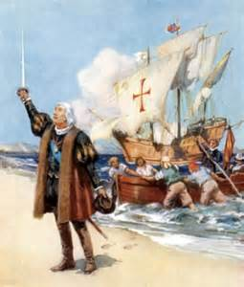  What were the motivations of the explorers such as Columbus?
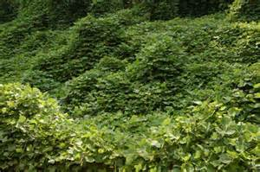  How can we compare kudzu to what occurred with smallpox during the Columbian Exchange? | 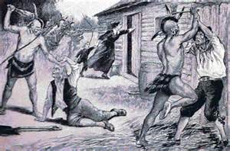  Why did most of the wars with the natives begin?  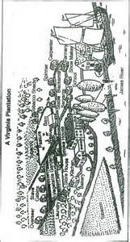  What was the effect of all of them?
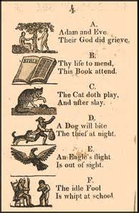  This is the New England  Primer, a colonial text. How  did it teach reading? | How is this Plantation different from a colonial farm?

