The Era of Good Feelings
Political events, issues, and personalities that lead to sectionalism

Why do you think the Panic of 1819 shake people’s nationalistic confidences?

How is the issue over immigration at this time similar to modern day concerns over it?

Henry Clay’s American System was supposed to balance the interests of the North and South. Did he succeed?
The early 1800’s was a time marked by ______________ _____________and ____________ ______________. The reality is that even though people feel united, over time the North and South divide over several issues. So, what are the issues?
I. Panic of 1819
- The U.S. faces its first nation-wide economic ________________________.
  - The National Bank gives credit to people wanting to move ________ but it loans out more money than it has.
  - Meanwhile, the U.S. owes _____________________ money and in 1819, they ask for it back. The Bank asks the settlers to pay back the loans, people get scared and ___________________ all their cash from the bank, leaving the United States totally broke.
- Effects of the Panic:
1. Shook many people’s nationalistic confidences
2. Westerners and Southerners begin to criticize the _____________________
-----------------------------------------------------------------------------------------------------------------
II. Immigration
- Between 1825-1855: + 5 million immigrants entered the United States and settled in poor northern cities. They were an asset as a source of _______________ in the factories.
- The South feared that immigrants would increase northern populations and give the North more ____________________________ in Congress. The North itself was divided on the topic of immigration: northerners who were born in the U.S. resented immigrants who they say took their jobs
  - Led to the rise of _______________________ who opposed immigration to protect the interest of native-born citizens.
  - Most powerful group: ___________________________. They won a few elections but did not have enough support to remain in politics.
-----------------------------------------------------------------------------------------------------------------
III. Monroe Doctrine (1823)
- President Monroe (5th President) sees nationalism fading and tries to unite Americans with the Monroe Doctrine
  - Stated that the U.S. would not tolerate _______________________ intervention in the Western Hemisphere
- Effect: Monroe tried to unite Americans against Europeans but sectional differences were too strong.
-----------------------------------------------------------------------------------------------------------------
IV. Henry Clay’s American System
(Remember him???He is the one Andrew Jackson accused of making a “corrupt bargain” with John Quincy Adams to deal for the presidency?)
- As Secretary of State, Clay creates the system to enhance the American economy after the Panic of 1819:
1. Protective _________ - trying to help northern businesses compete against Europe
2. Creation of a strong National ____________
3. Internal improvements – systems of _______________ and ________________ to improve industry

V. Tariff of 1828

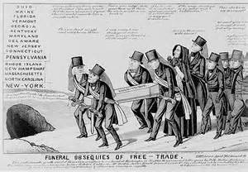
In this cartoon, free trade is shown as a coffin.
What action is this cartoon referencing?

What is the cartoonist’s main point?

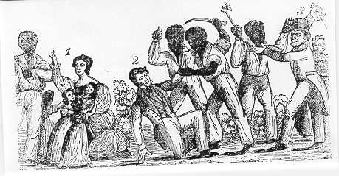

This is a picture depicting Nat Turners rebellion. Which type of strategy do you feel would be more effective for abolitionists (those who oppose slavery) to achieve their goals – violent or non-violent? Please explain.

The tariff was a tax on ____________________ goods (from other countries)
- North ____________________ the tariff as it raises the price of imported goods, which encouraged people to buy ________________ products.
- South ____________________ it as European goods were cheaper than American goods.
  - They call it the “Tariff of _____________________________”
  - Reasoning:
1. Southerners felt that the government was only protecting
____________________industry, as most products made in North.
2. Other countries begin to impose __________________ on the U.S in
retaliation, which makes it hard for the South to _______ their goods.
-----------------------------------------------------------------------------------------------------------------
VI. Jackson and the Bank of the U.S.
- Jackson is re-elected in the Election of ______________ because he opposes the national bank as he believes it favors wealthy businessmen over the common man.
- Jackson comes up with a solution to the National Bank:
1. Take all the money from the National Bank and put it into certain _____________ Banks
2. Pet Banks give out loans more loans are given out, however, than is available in the gold standard
- Effect: loans lead to inflation which causes a depression
-----------------------------------------------------------------------------------------------------------------
VII. John C. Calhoun and the South Carolina Nullification Crisis
- Southerners led by John C. Calhoun begin to demand that the federal government _____________ the tariff
  - Says that states have the right to nullify a unconstitutional law
- Calhoun threatens to ________________________ if tariff is not abolished, which shows severe sectional disagreements and differences between North and South.
-----------------------------------------------------------------------------------------------------------------
VIII. Nat Turner’s Rebellion
- The same year as the Nullification Crisis, the debate between North and South over ___________________reaches a dramatic point
- Nat Turner, a slave, organizes a revolt that kills 160 black and white Americans, which frightens southerners
- ____________________________ are instituted to tighten the South’s grasp on slaves
-----------------------------------------------------------------------------------------------------------------
IX. New Political Parties Emerge
- Jackson’s political opposition was made up of former Federalists. They change their name to the ___________________________
- Platform:
1. _____________________________ should be more powerful than the executive branch 2. Federal government should _____________________ the economy.

