The Era of Good Feelings
Political events, issues, and personalities that lead to sectionalism
The early 1800’s was a time marked by national pride and political unity. The reality is that even though people feel united, over time the North and South divide over several issues. So, what are the issues?
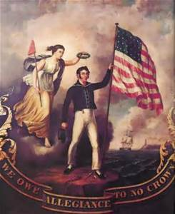

I. Panic of 1819
The U.S. faces its first nation-wide economic depression. The National Bank gives credit to people wanting to move west but it loans out more money than it has. Meanwhile, the U.S. owes Britain money and in 1819, they ask for it back. The Bank asks the settlers to pay back the loans, people get scared and withdraw all their cash from the bank, leaving the United States totally broke. The effects of the Panic were that it Shook many people’s nationalistic confidences and Westerners and Southerners begin to criticize the Bank.

II. Immigration
Between 1825-1855, over 5 million immigrants entered the United States and settled in poor northern cities. They were an asset as a source of unskilled labor in the factories. The South feared that immigrants would increase northern populations and give the North more representation in Congress. The North itself was divided on the topic of immigration: northerners who were born in the U.S. resented immigrants who they say took their jobs This led to the rise of Nativism - groups who opposed immigration to protect the interest of native-born citizens. The most powerful Nativist group was the Know-Nothings. They won a few elections but did not have enough support to remain in politics.

III. Monroe Doctrine (1823)
President Monroe, who was the 5th president and served after Madison, sees nationalism fading and tries to unite Americans with the Monroe Doctrine. It stated that the U.S. would not tolerate European intervention in the Western Hemisphere. Monroe tried to unite Americans against Europeans but sectional differences were too strong.
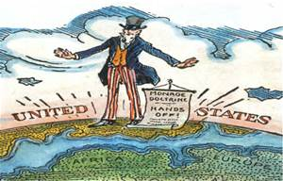

IV. Henry Clay’s American System
Remember him? He is the one Andrew Jackson accused of making a “corrupt bargain” with John Quincy Adams to deal for the presidency. He becomes Secretary of State under Adams and creates the American System to enhance the economy after the Panic of 1819. His system includes:
1. Protective Tariff - trying to help northern businesses compete against Europe
2. Creation of a strong National Bank
3. Internal improvements – systems of roads and canals to improve industry
V. Tariff of 1828
The tariff was a tax on imported goods, which are products that come from other countries. The North supported the tariff as it raised the price of imported goods, which encouraged people to buy American products. The South opposed it as European goods were cheaper than American goods. The South called the tariff “The Tariff of Abominations.” The reasoning behind this is that Southerners felt the government was only protecting Northern industry, as most products are made in North. After the tariff, other countries begin to impose boycotts on the U.S goods in retaliation, which makes it harder for the South to export their goods.

VI. Jackson and the Bank of the U.S.
Andrew Jackson is re-elected in the Election of 1832 because he opposes the national bank as he believes it favors wealthy businessmen over the common man. Jackson comes up with a solution to the National Bank:
1. Take all the money from the National Bank and put it into certain Pet Banks
2. Pet Banks give out loans (more than in the gold standard)
The effect is that that the loans cause major inflation which causes another depression.

VII. John C. Calhoun and the South Carolina Nullification Crisis
Southerners led by John C. Calhoun begin to demand that the federal government repeal the tariff. They believe that states have the right to nullify an unconstitutional constitutional law. Calhoun threatens to secede if the tariff is not abolished, which shows severe sectional disagreements and differences between the North and South.

VIII. Nat Turner’s Rebellion
In the same year as the Nullification Crisis, the debate between North and South over slavery reaches a dramatic point. Nat Turner, a slave, organizes a revolt that kills 160 black and white Americans, which frightens southerner.
Slave codes are instituted to tighten the South’s grasp on slaves.
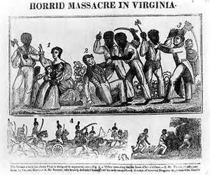

IX. New Political Parties Emerge
Jackson’s political opposition was made up of former Federalists. They change their name to the Whig Party. Their platform consists of the ideas that Congress should be more powerful than the executive branch and the federal government should help support the economy.
