British and American spelling
There are several areas in which British and American spelling are different. These are the main ones to be aware of.

Words ending in –re

British English words that end in -re often end in -er in American English:

British | US
centre | center
fibre | fiber
litre | liter
theatre | theater or theatre

Words ending in -our

British English words ending in -our usually end in -or in American English:

British | US
colour | color
flavour | flavor
humour | humor
labour | labor
neighbour | neighbor

Edgar Allen Poe
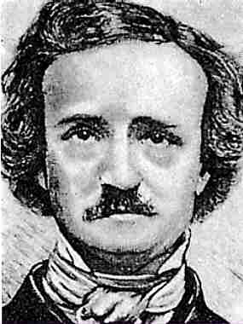

Edgar Allen Poe was most known as a writer of highly emotional works, many of them considered horror stories. He is considered one of the Romantic Poets as the intent of his work is to illicit certain emotions from the reader. This means that the reader will essentially FEEL what is being written. For example, read the opening lines from his most famous work “The Raven…”

Once upon a midnight dreary, while I pondered, weak and weary,
Over many a quaint and curious volume of forgotten lore--
While I nodded, nearly napping, suddenly there came a tapping,
As of some one gently rapping, rapping at my chamber door.
"'Tis some visitor," I muttered, "tapping at my chamber door--
Only this, and nothing more."
Ah, distinctly I remember it was in the bleak December;
And each separate dying ember wrought its ghost upon the floor.
Eagerly I wished the morrow;-- vainly I had sought to borrow
From my books surcease of sorrow-- sorrow for the lost Lenore--
For the rare and radiant maiden whom the angels name Lenore--
Nameless here for evermore.

What specific words does he use to bring out emotions within the reader?
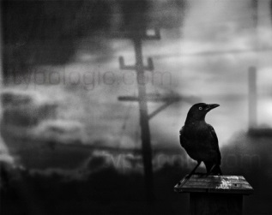
Henry David Thoreau
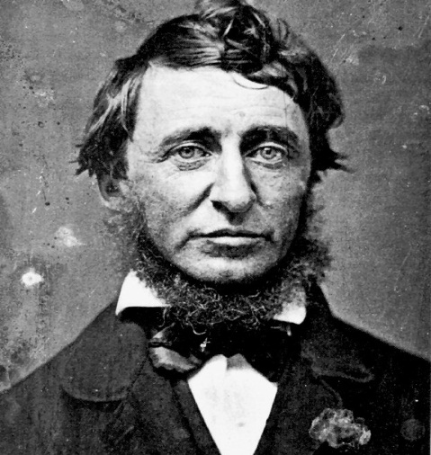

Henry David Thoreau was another famous Transcendentalist. Like other authors in the movement, he stressed the idea of self-reliance and a connection with nature. In fact, when he wrote his most famous work Walden, he was living in isolation in the woods for two years.

Thoreau was also a major proponent of the idea of civil disobedience. He believed that if a law was unjust, a person had a right not to obey it. He exemplified this idea by not paying his taxes in protest of slavery and the Mexican-American War. He stated that he did not want to pay for these abuses of power so he went to jail instead. Two famous freedom fighters would read his works and be inspired: Gandhi and Martin Luther King, Jr.

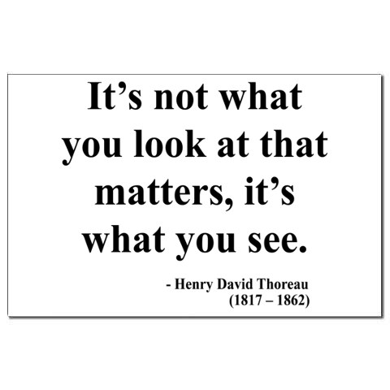

James Fenimore Cooper
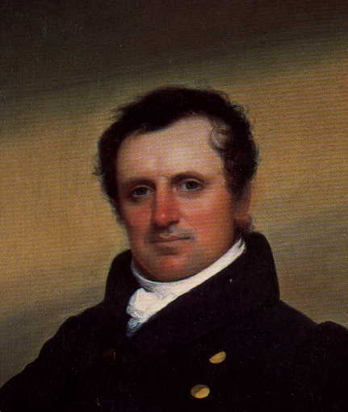

James Fenimore Cooper was an American writer who was admired, like his friend Washington Irving, by both American and European readers and writers. His books are about both politics and life on the frontier, although his most famous writings are about the latter (frontier life).

Fenimore’s writings brought much admiration along with the criticism, specifically when he wrote about clashes between the Native Americans and white settlers. He not only portrayed Native Americans as savages with no feelings (as was a predominant notion at the time), but also as compassionate and worthy of our praise. You can see this characterization in his most famous work The Last if The Mohicans.

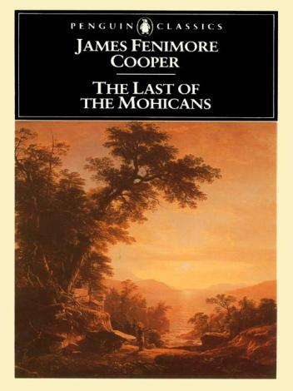

Nathaniel Hawthorne
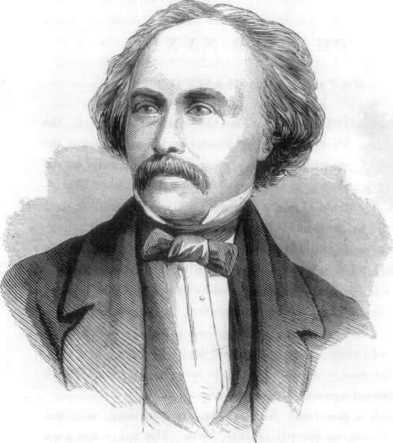
Nathaniel Hawthorne was an American writer whose themes focused in the lives of the Puritans living in New England. Many of his novels focused on the inherent evil of many and the sins they commit.

His most famous novel was titled The Scarlett Letter, in which a young woman has a child out of wedlock and is forced to publically pay for her sin by wearing a red letter A attached to the front of her dress (the A stands for adultery). The novel was an instant best seller despite its dark and painful theme.

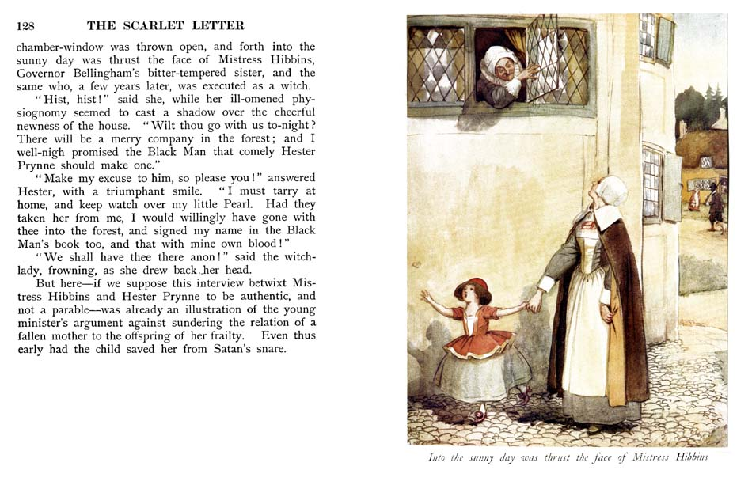

Ralph Waldo Emerson
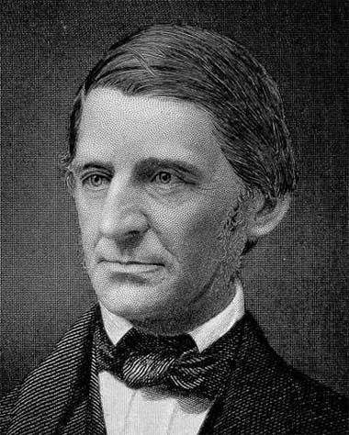

Ralph Waldo Emerson was known as a Transcendentalist. His works, which include the famous writings Nature and Self-Reliance, stressed a connection to nature and the natural world as well as a belief in an individual’s sense of being. He did not believe in conformity and was most conscious of the effect the literature had on the reader and their individual interpretation and feelings.

Emerson spent much of his life speaking publicly as well as writing and was very supportive of the abolitionist movement against slavery. He also often put down the treatment of the Native Americans by the American government.

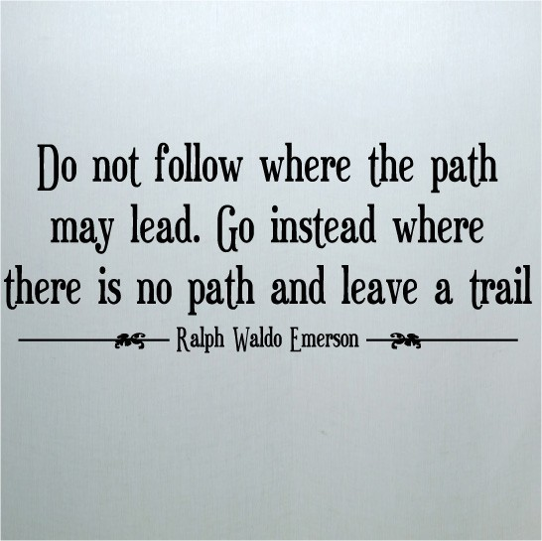

Transcendentalism
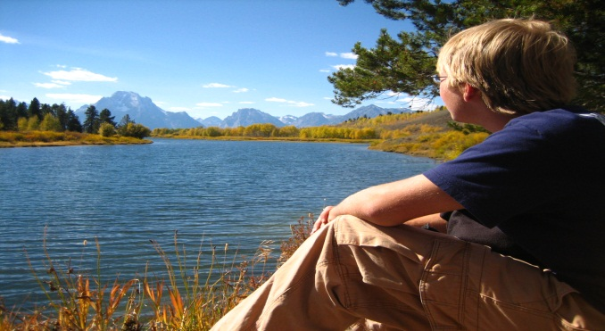

Transcendentalism was a literary movement that was influenced by the ideas of the Romantic Movement. Authors of this group stress individualism and the ability of a person to make their own choices, as opposed to a conformist path chosen by religious beliefs. They advocated for living a simple life among the natural surroundings. Two famous authors of this tradition were Ralph Waldo Emerson and Henry David Thoreau.

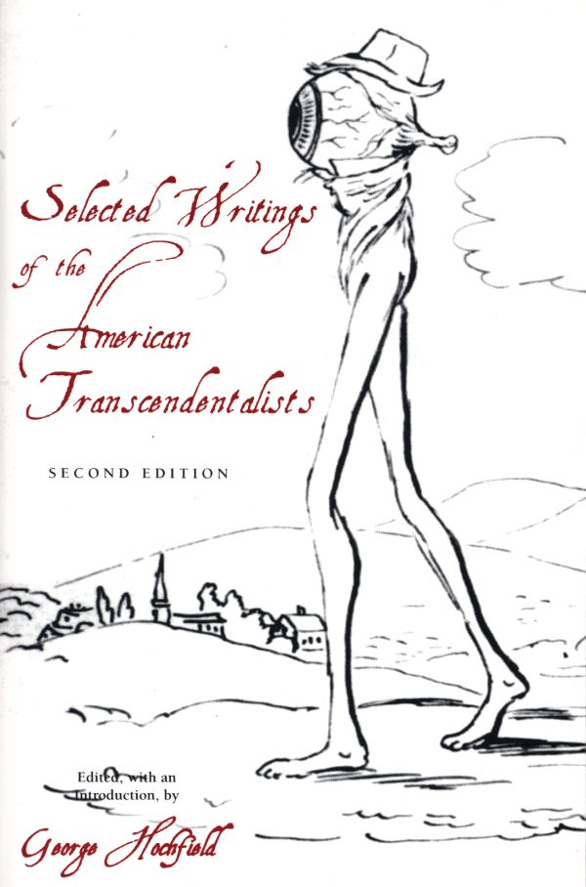

Washington Irving
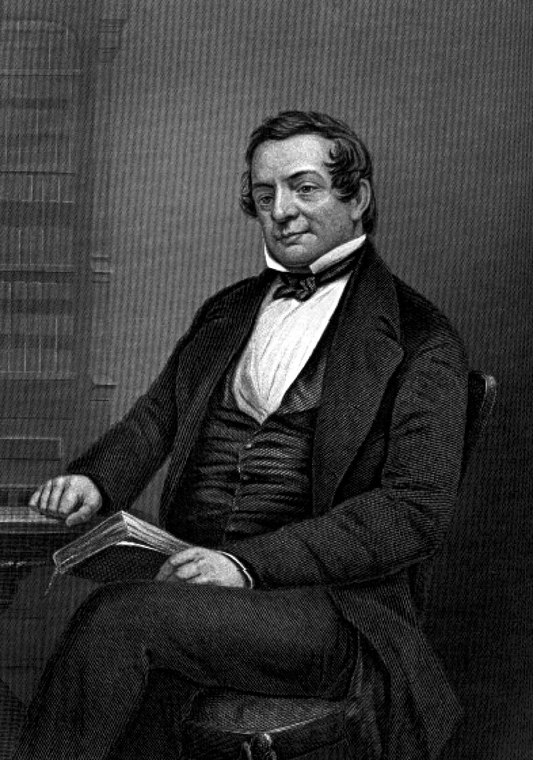

Washington Irving was an American author that was appreciated by both American and European readers. In fact, many would say he one of the first internationally best-selling authors. This is significant as prior to his publications, European authors are what was popular.

Irving’s stories mostly took place in the Hudson River Valley in New York. His most famous story, The Legend of Sleepy Hollow, centers around the tiny town of Tarry Town, New york.

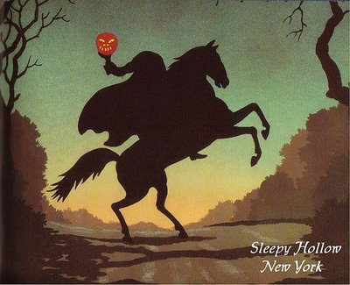

Washington Irving was also known for being part of a literary circle known as the Knickerbocker School. The men who were a part of this group wanted to promote and protect American authors (especially when it came to copyright issues) and to put New York on the internation map as a literary center, like London or Paris.

