Memorial #1 NY
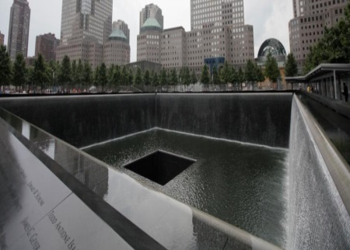
(From the website) The 9/11 Memorial is located at the site of the former World Trade Center complex and occupies approximately half of the 16-acre site. The Memorial features two enormous waterfalls and reflecting pools, each about an acre in size, set within the footprints of the original Twin Towers. With its grove of trees, the Memorial’s plaza is an actual green roof for the structure housing the 9/11 Memorial Museum, a train station and other facilities 70 feet below street level. The nearly 3,000 names of the men, women, and children killed in the attacks of September 11, 2001 and February 26, 1993 are inscribed on bronze parapets surrounding the twin Memorial pools.

What are your thoughts on the design of this memorial? Be specific about the features…don’t just say its cool.
______________________________________________________________________________________________________________
Memorial #2 PA
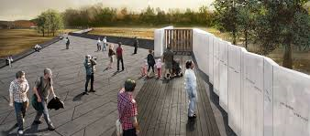
(From the website) On September 10, 2011 the first features of the Flight 93 memorial were completed and dedicated. These include the new entrance, new roads, and the Memorial Plaza at the crash. The Memorial Plaza marks the edge of the crash site, which is the final resting place of the passengers and crew of Flight 93. The Memorial Plaza is made of various different elements. The plaza is designed to be self-guided. Orientation panels explain the basics of the plaza and interpretive panels provided a general overview of the story. The long sloping black wall marks the northern edge of the larger crash site and debris field. The field and woods beyond is the final resting place of the passengers and crew. Benches offer places of rest and contemplation. Visitors can leave tributes in small niches in the wall.
What are your thoughts on the design of this memorial? Be specific about the features…don’t just say its cool.
______________________________________________________________________________________________________________
Memorial #3 DC
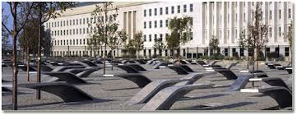
(From the website) The Pentagon Memorial captures that moment in time at 9:37 a.m. when 184 lives became intertwined for eternity. Each victim’s age and location at the time of the attack have been permanently inscribed into the Memorial by the unique placement and direction of each of the 184 Memorial Units. Visitors to the Memorial may look up a victim’s name and birth year on the locator stone within the Pentagon Memorial Gateway. Each Memorial Unit is a cantilevered bench, a lighted pool of flowing water, and a permanent tribute, by name, to each victim, in one single element. Each memorial bench is made of stainless steel and inlaid with smooth granite. Each Memorial Unit contains a pool of water, reflecting light in the evenings onto the bench and surrounding gravel field.

What are your thoughts on the design of this memorial? Be specific about the features…don’t just say its cool.
______________________________________________________________________________________________________________
After looking at the ways that we have created memorials, what are some main similarities you see between them?

Why do you think those similarities exist?

What are some major differences?

Why do you think those differences exist?

Do you think memorials are important to create as a society? Be honest. Fully explain your reasoning behind your answer.

Pick an event in your life that Americans in the future should study. Describe how you would design the memorial and explain why you did it this way.

