Adams has to follow President Washington into the presidency. What are some advantages to that?  What are some disadvantages? | Inherited Issues from Washington: Britain v France.  Impressment:  Jay’s Treaty of 1793 (under Washington):  Britain’s agreement –  Failure: | Land Expansion: Pinckney’s Treaty
XYZ Affair 1797 | The Presidency of John Adams  Federalist: 1797-1801  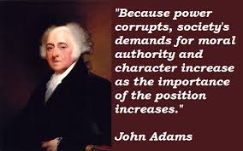 | Alien and Sedition Acts 1798
Virginia and Kentucky Resolutions 1798 | Election of 1800 – Adams vs Jefferson | Midnight Judges

Political Cartoon Practice: Adam’s Issues
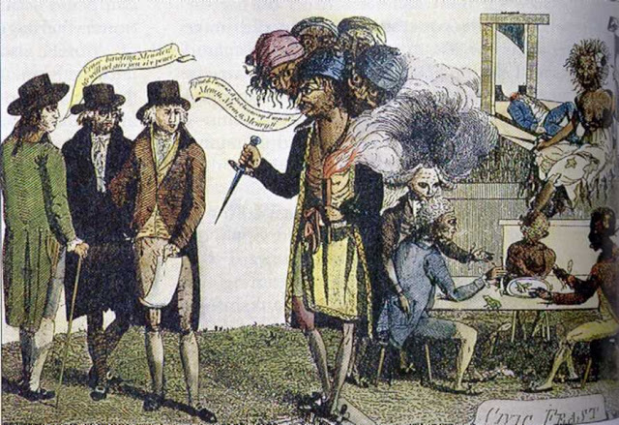
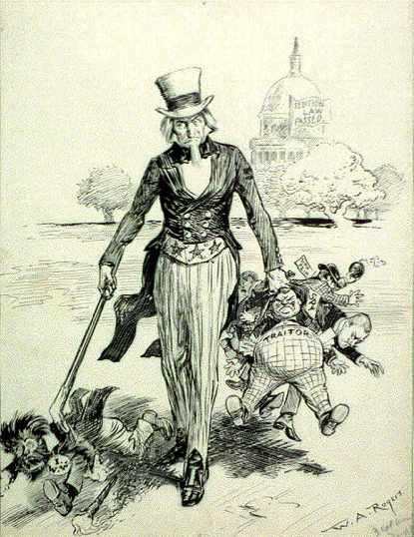
XYZ Affair Alien and Sedition Acts

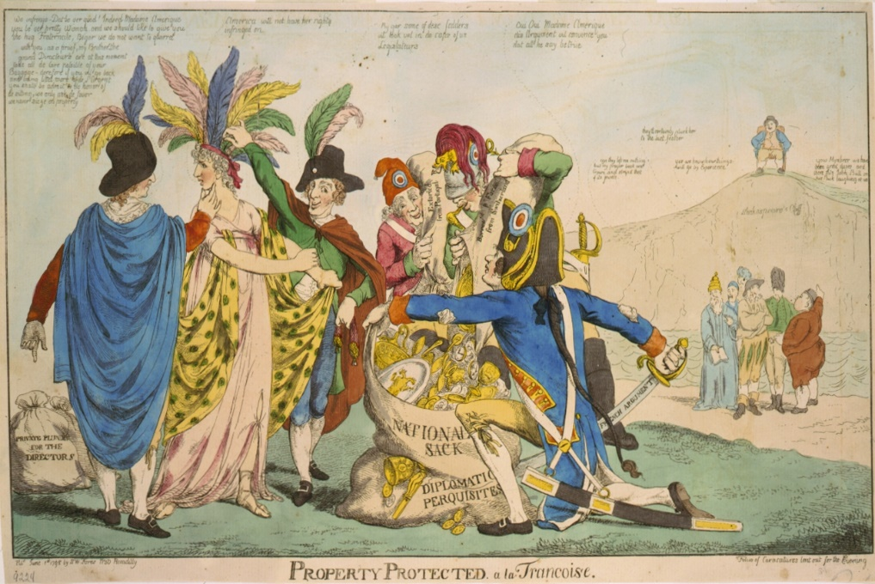
1. For each cartoon, what do you see?
2. What is the message of each?
3. How does the point of view differ between the two cartoons about the XYZ Affair? Hint: Top cartoon done by an American, bottom done by a British cartoonist.

