#1 Trail of Tears
Trail of Tears
Cherokees are relocated to reservations in Oklahoma. They were forced to walk 800 miles. Many died of disease, starvation, and exposure.

*Add to notes: Worcester v Georgia – Supreme Court says Indians can stay on land but Jackson has the removed anyway.

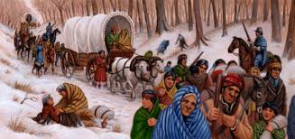

#2 Webster-Asheburton Treaty
Webster-Asheburton Treaty of 1846: In the 1840’s, the US and Britain were fighting over the border between the US and Canada. This treaty created the border to solve the dispute.

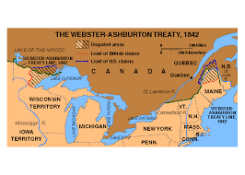

#3 Texas
Texas
Mexico gained independence from Spain in 1821, and Sam Houston led Americans into the territory to settle. General Santa Anna takes control of the gov’t and tightens control. Texans declare their independence and take a stand against Mexico at The Alamo . Americans lose, but the event becomes a battle cry for other Texans to fight: “Remember the Alamo”. When Texas wins, they ask the U.S. to annex them. The controversy arises over Texas as it would be admitted as a slave state.

In the Election of 1844, James K. Polk runs on a pro-annexation platform and everyone votes for him! This shows Congress that people wanted Texas to be annexed.

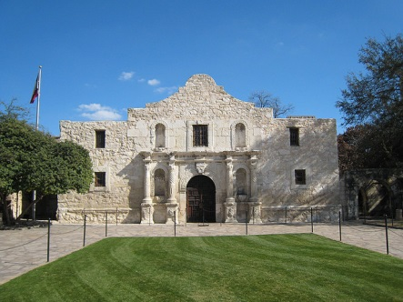
#4 Annexation of Oregon
Annexation of Oregon
After the annexation of Texas, Polk turned to Oregon. Britain and US owned jointly until 1843 when Americans began to settle in large numbers. President Polk told Britain that the US had a right to Oregon Territory up to the 54º 40’. Americans united under the cry “54-40 or Fight!” Britain gave up the territory because the US had:
1. Become an important consumer of British goods
2. Britain felt the area was no longer profitable

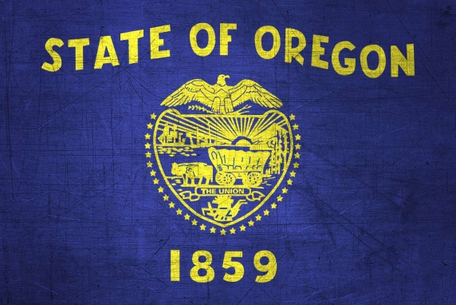

#5 Mexican-American War
Texas fights for independence. After the Alamo is lost, people rally behind the victims. Eventually, the Texans defeat the Mexican Leader Santa Anna and take him hostage. They bargain: independence for freedom. Texas becomes its own country.

Texas Annexation. The northern states resist making Texas a state because of slavery but Polk manages to make it happen.

Mexican-American War. Mexico feels we took Texas from them and then we try and buy more land. They refused the deal so we marched to the border and won a few victories.

Mexican Cession. In the treaty to end the war, the US purchases California and New Mexico.

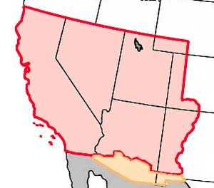
#6 California
California
California becomes a US territory with the Treaty of Guadalupe-Hidalgo (1848). One year later, gold is discovered and many people, called 49ers traveled to the area. Californian’s draft their own constitution and become a state with the Compromise of 1850.
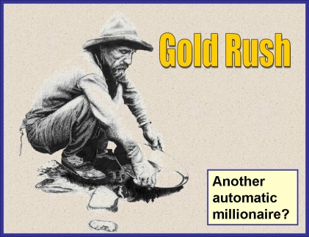

#7 Gadsden Purchase
Gadsden Purchase
The US wants to build a transcontinental railroad, but it needs land in the Southwest. New Mexico was gained through the Treaty of Guadalupe-Hidalgo. President Franklin Pierce sends James Gadsden to purchase land for the railroad. They paid $10 million for the small piece of land.
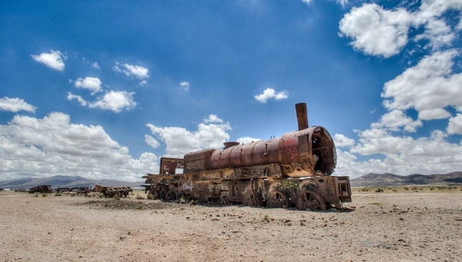

Wilmot Proviso
The Wilmot Proviso
After the US acquires Ca. and NM, a debate rages on about slavery. David Wilmot (Pa) proposed banning slavery from new territories. Northerners and southerners once again divide.
