Intro Unit Study Guide Name: ____________
IU.1 I can explain each of the six themes of American History 1 and sort examples into each category.

1. Another theme we will track is the theme “Freedom and Power.” It has to do with balance. What are the two entities we trying to balance?

2. We did project about our version of the American Dream - what is the definition of the term ”American Dream?”

3. In the exploration/settlement/expansion theme, we will be studying whether an action that influenced movement was a push or a pull factor. What is the difference and give an example?

a. Push factor: ___________________________
example: _______________________________

b. Pull factor: ____________________________
example: _______________________________

4. When it comes to studying the different wars, what two aspects of the war do we want to mainly focus on?

IU.2 I can identify the five major geographic regions in the United States and compare how human experiences are impacted by each region.
Here is a list of the five regions: Coastal plain, Mountain, Interior Lowland, Great Plain, and Desert.

1. What is one common feature of both Interior Lowlands and Great Plains?

2. Why is it important to cover up in the desert even though it is hot?

3. In the desert, where do the rivers come from since there is very little rainfall?

4. In the mountains, we stated that we would need small shelters. Why is that?

5. In which region would we have a diversity of fruits and vegetables at our disposal to eat, as well as seafood?

IU.3 I can describe events in terms of INSPECT (ideological, Natural, Social, Political, Economic, Cultural, Technological)
Next to each modern day example, please state which the example belongs to (from above list):

1. Immigrants to the US fear children may lose their heritage as their children become more “American.”__________________

2. Google’s self-driving cars are picking up interesting images of America. _____________________

3. Obama states that he will wait until after elections to implement an executive order about immigration.__________________________________

4. What should the American people fight for: fair treatment or equal treatment? And do they know the difference? ____________________________

5. Prisons around the US experiment with new inmate education programs.____________________________

IU.4 I can describe how an object or visual might be used as a primary source.
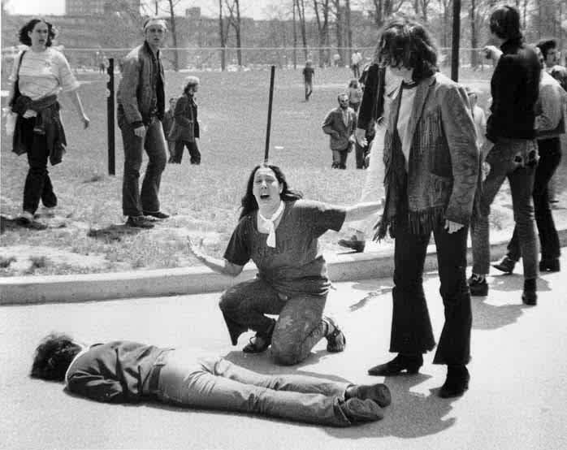
Answer these questions on the back:
1. Describe the people involved.
2. Describe the activities.
3. Make one inference about what you think this visual has captured.

