History Detective: what is going on?

[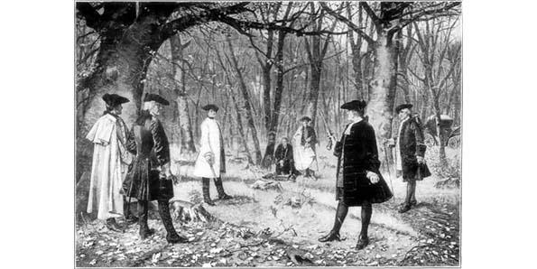](http://mediad.publicbroadcasting.net/p/kalw/files/201307/Alexander-Hamilton-vs.-Aaron-Burr.jpg)