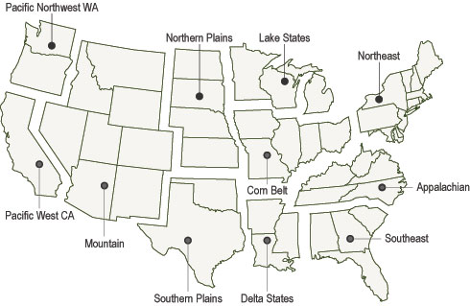

Why is geographical knowledge important to the study of history?

Geography of the United States