On the footprint below, describe the event that took place and state the effect the event had on America during the Revolution. Then on the back, draw a picture of the event (use color). Picture will be graded on effort.
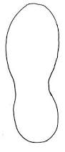
How does this event lead to the American Revolution?

On the footprint below, describe the event that took place and state the effect the event had on America during the Revolution. Then on the back, draw a picture of the event (use color). Picture will be graded on effort.

How does this event lead to the American Revolution?

