History Detective: What is happening in this picture?
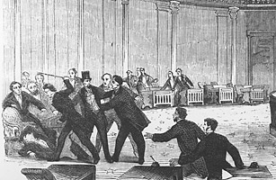

Economic, social, and political events from the Mexican War to the outbreak of the Civil War.

Translation: What happened from 1846 to 1861 that resulted in the Civil War?
Event | Visual | Notes
Missouri Compromise | 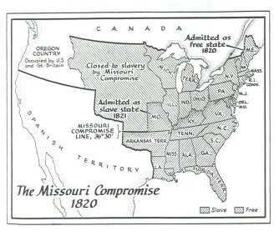 | The Missouri Compromise was passed in _____________ in order to preserve the balance between free and slave states.  States would be admitted in pairs: one slave, one free. All states south of the Missouri border would be admitted as _____________ states and all states north of the border would be admitted as __________ states.
Compromise of 1850 | 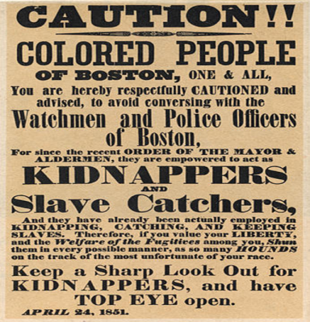 | The Compromise of 1850 was intended to settle the issue of slavery in land acquired after the Mexican War (California and the New Mexico Territory).  1. ________________________ would be admitted to the Union as a free state.  2. The issue of slavery in Utah and the New Mexico Territory would be decided upon using  __________________ _________________________, meaning that people in the area could  choose whether or not they wanted to allow slavery.  3. The ____________________ ________________ Act stated that free states had to return  escaped slaves to their owners in the South.
Kansas-Nebraska Act  (1854) | 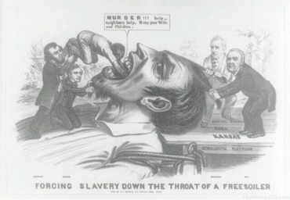 | The Kansas-Nebraska Act tells Kansas and Nebraska that they can use popular sovereignty to decide whether slavery would be permitted. This means…  (Technically, according to the Missouri Compromise, they should be __________ states)  After its passage, people from the North and South rush to Kansas to influence the vote on slavery. The results were disastrous…  Pro-________________ and _______________________ forces clashed violently on a regular basis.  This incident would cause an uproar in Congress…
Bleeding Kansas | 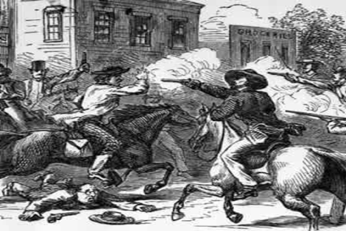
Sumner-Brooks Incident  (1854) | 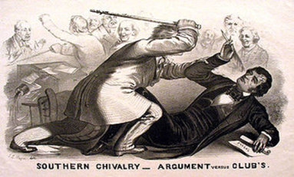 | Charles Sumner spoke for __________ entire DAYS in the Senate, criticizing the South and the authors of the Kansas-Nebraska Act.  Preston Brooks, a South Carolina Senator and relative of one of the authors of the Act, was insulted by the speech. Brooks approached the Senator on the Senate floor and beat him with a heavy cane, almost killing him, proving how _____________________________ people were about slavery.
Dred Scott v. Sanford  (1857) | 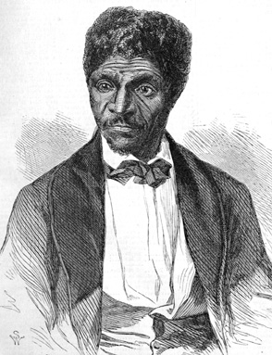 | Dred Scott was a slave from Missouri who moved with his owner to Illinois, a free state. They lived there for four years, and then returned to Missouri, where the owner died. Dred Scott then sued for his freedom, claiming that because he lived in free territory, he had the right to be free.  Decision: The court decided against Dred Scott.  1. Dred Scott was a slave, not a ___________________, so he had no right to sue.  2. The government does not have the right to take a man’s ______________________, even in free territory.  Significance: Implies that slaves are ____________________ and so strikes down the Missouri Compromise as the Supreme Court basically implies that slavery can still exist in free territories.
Republican Party | 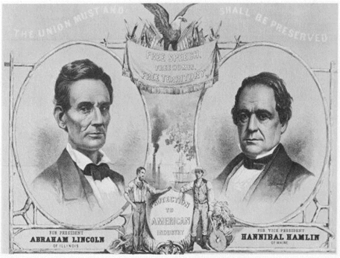 | At the time, there were four political parties: the _____________________ (former Democratic-Republicans), the ______________ (former Federalists), the _______________________ Party (abolitionists), and the ________________________________ (Nativists). The Republican Party is a coalition of people from all four groups.  Stance: Did not call for immediate abolition of slavery, but did not want slavery to spread to new territories.
Lincoln-Douglas Debates  (1858) | 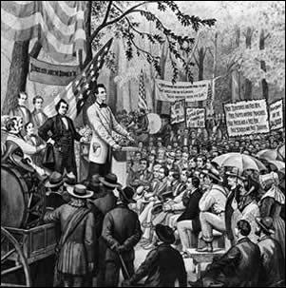 | In 1858, Republican Abraham Lincoln and Democrat Stephen Douglas square off in the Illinois Senate Race. The two candidates debated publically over ________________________.  Lincoln: slavery should __________ be extended into new territories.  Douglas: slavery could not be allowed in territories where there were no ________________  to monitor it. Idea would be known as the ________________________ Doctrine.  Douglas wins the election (he wants to be the next president) but loses the South’s support when he disagrees with the Dred Scott Decision.
Slave Codes | 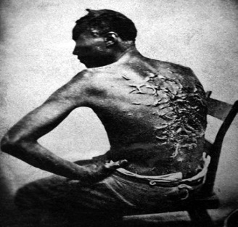 | Slave Codes were laws in each state that defined the role of slaves and masters, and would severely limit the actions of slaves. Many ______________________ looked to these laws as a sign to take action against slavery as change did not seem to come fast enough.  Harriet Tubman was an escaped slave who returned to the South _______ times to help slaves escape on the _________________________ _______________________________, a network of people who helped slaves escape to the free North.
Publication of Uncle Tom’s Cabin  (1852) | 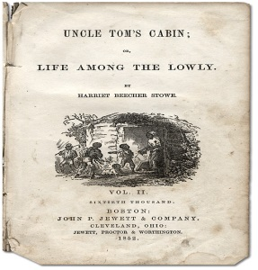 | Harriet Beecher Stowe was a white, middle-class northern woman who opposed slavery. She wrote Uncle Tom’s Cabin, a fictional story about the horrors faced by a slave family in the South.  Many ________________________ thought the account was true and it inspired them to join the abolitionist movement. Many __________________________ denounced it as a work of fiction.  Would cause further divisions between the two regions.
John Brown and the Incident at Harper’s Ferry  (1859) | 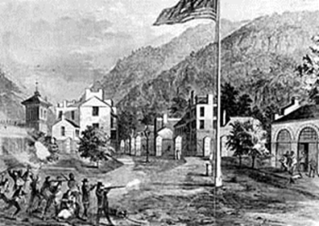 | John Brown was a radical white abolitionist.  Oct. 1859, he and his followers raid an ______________________ in Harper’s Ferry, Virginia. He had intended to give the weapons to slaves to start a rebellion. U.S. Troops stop the raid and hang John Brown.  Southern resentment towards ______________________ grows.
The direct causes of the Civil War
Fort Sumter
Lincoln wants to send food and supplies to fort but does not want it to look like an act of ________________.

Confederate troops attack the fort on April 12, ____________ and Lincoln asks for people to volunteer to fight.

Border states are forced to choose: KY, MO, MD stay with the Union and VA, NC, AK, and TN join the South.

Richmond, VA – Southern Capital
Secession
*Lincoln’s win would be the immediate cause for the _______________ as several states decide to secede from the Union.

The South feels that Lincoln will abolish slavery so delegates from South Carolina meet and formally secede in December of ___________. Many states follow and others warn that if Lincoln uses force, they will join to.

South creates its own gov’t called the Confederate States of America and chooses _________________ Davis as President.

Election of 1860
__________________ are split among sectional lines. The North wants Stephen Douglas but South does not feel he is pro-slavery enough. Douglas wins nomination but Southern Democrats choose a third candidate.

__________________ decide Abraham Lincoln is safest candidate. The South does not even put him on the ballot!

__________________wins as the Democrats split their votes.

