Analyze the effects of territorial expansion and the admission of new states to the union from 1801 to 1850.
--------------------------------------------------------------------------------------------------------------------------------------------------------------------------------------------------------------------
Annexation of Oregon
After the annexation of Texas, Polk turned to Oregon. Britain and US owned jointly until _________when Americans began to settle in large numbers. President Polk told Britain that the US had a right to Oregon Territory up to the 54º 40’. Americans united under the cry “54-40 or _________!” Britain gave up the territory because the US had:
1.
2.
Webster-Asheburton Treaty of ___________: In the 1840’s, the US and Britain were fighting over the border between the US and __________________. This treaty created the border to solve the dispute.
#4 #2

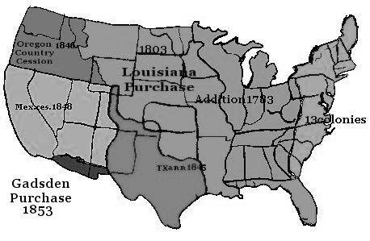

#6 California
California becomes a US territory with the Treaty of Guadalupe-Hidalgo (1848). One year later, _________ is discovered and many people, called ________________ traveled to the area. Californian’s draft their own constitution and become a state with the Compromise of 1850.

Gadsden Purchase
The US wants to build a transcontinental ________________________, but it needs land in the Southwest. New Mexico was gained through the Treaty of Guadalupe-Hidalgo. President Franklin Pierce sends James Gadsden to purchase land for the railroad. They paid $10 million for the small piece of land.
#7

#3 Texas
Mexico gained independence from Spain in 1821, and Sam Houston led Americans into the territory to settle. General Santa Anna takes control of the gov’t and tightens control. Texans declare their independence and take a stand against Mexico at The _________________. Americans lose, but the event becomes a battle cry for other Texans to fight: “_______________________________________”. When Texas wins, they ask the U.S. to _______________________ them. The controversy arises over Texas as it would be admitted as a _____________________ state.

In the Election of _____________, James K. Polk runs on a pro-annexation platform and everyone votes for him! This shows Congress that people wanted Texas to be annexed.
Trail of Tears
Cherokees are relocated to reservations in _________________________. They were forced to walk ______ miles. Many died of disease, starvation, and exposure
#1

The Wilmot Proviso
After the US acquires Ca. and NM, a debate rages on about slavery. David Wilmot (Pa) proposed ________________ slavery from new territories. Northerners and southerners once again divide
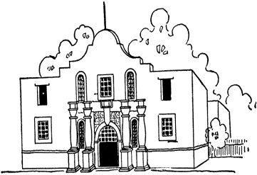
#5
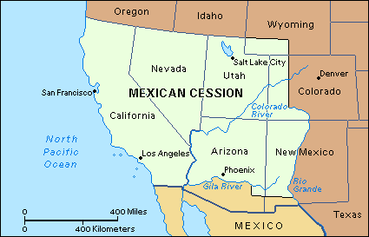
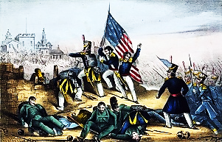
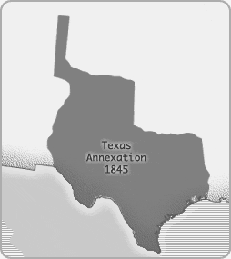

Texas Fights for Independence (1836) Texas Annexation (1845) Mexican-American War (1846-1848) Mexican Cession and the Treaty Sectionalism
of Guadalupe-Hidalgo 1848)

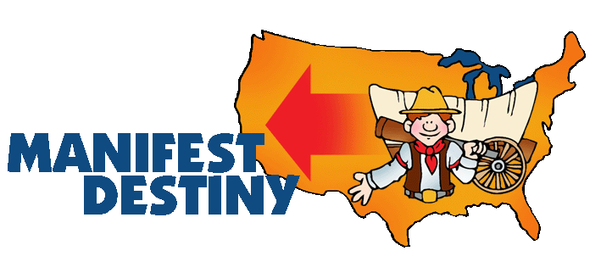
Mapping Territorial Expansion (1800 – 1850)

Territory | Year | Who was the president? | How was it acquired?  Who was it acquired from? | What states are included? | What conflicts did it cause?
Louisiana Purchase

Florida

Texas

Oregon Territory

Mexican Cession

Gadsden Purchase

