African Americans
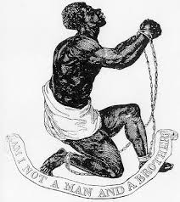
Gains Losses

Primary Source: Read and answer the questions.
…we have been & now are Taxed both in our Polls and that small Pittance of Estate which through much hard Labour & Industry we have got together to Sustain our selves…we are not allowed the Privilege of freemen in the State having no vote or Influence in the Election of those that tax us…yet many of our Colour…have cheerfully Entered the field of Battle in defense of the Common cause and that…against a similar Exertion of Power (in regard to taxation)

1. What were the authors of this petition protesting against?

2. How did the authors use the American Revolution to support their cause?

Native Americans
Gains Losses

" BROTHERS-We have heard of the unhappy differences and great contention between you and Old England. We wonder greatly, and are troubled in our minds.

" BROTHERS-Possess your minds in peace respecting us Indians. We cannot intermeddle in this dispute between two brothers. The quarrel seems to be unnatural. You are two brothers of one blood. We are unwilling to join on either side in such a contest, for we bear an equal affection to both you Old and New England. Should the great King of England apply to us for aid, we shall deny him ; if the colonies apply, we shall refuse.

1. According to this quote by the Oneida, what is their
position in the war?

2. Why are they taking this position?

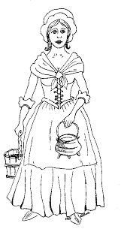
Women
Gains Losses

Abigail Adams, writing to her husband John Adams…
If particular care is not paid to the ladies, we are determined to instigate a rebellion, and will not hold ourselves bound by any laws in which we have no voice or representation.

…with regard to the education of my own children I feel myself soon out of my depth, destitute in every part of education…if we mean to have heroes, statesmen, and philosophers, we should have learned women.

1. According to Abigail Adams, what might possibly happen if the founders do not “remember the ladies?”

2. Why must women be educated, according to the text?

