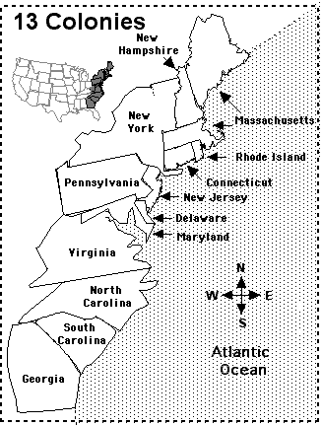

Colonial America Review – use the readings on the back to review the characteristics of the American colonies.

 | Climate and Geography | How They Made Their Money | Who settled the area? | Why do they become settlers?
New England Colonies
Middle Colonies
Southern Colonies

