The Myth of the Native American
1.01 I can explain how the geography of the North American continent led to the diversity of Native Americans in the years prior to settlement.

In the space below, draw in detail the popular image you have of a Native American. Label your drawing with explanations of what you have been told about them.

Modern Day Controversy; Flattery or Racism?
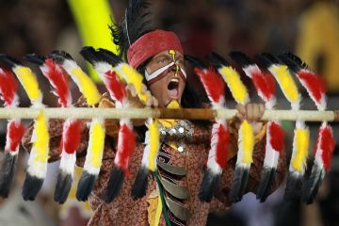
The above image if that of the Florida State Mascot: the Seminoles. Answer the questions below (from Upfront Magazine):
1. What details do you notice about the mascot?

2. Is this representation of Native Americans offensive or flattering? Explain your answer.

3. Why do you think so many pro sports teams and school teams use Native Americans as mascots?

-----------------------------------------------------------------------------------------------------
Article questions: From Upfront Magazine article “Insult or Honor?
1. After reading the article, why do you think Sioux tribe member Black Cloud sued for the local school to keep the Native-inspired nickname?

2. Why do so many professional sports teams resist the logo change?

