1.01 I can explain how the geography of the North American continent led to the diversity of Native Americans in the years prior to settlement.
Native American Groups Prior to Exploration
Northwest Coast  Plateau  California | 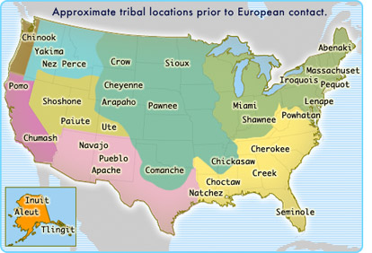 | Eastern Woodlands  Southeast  Great Plains
 | Great Basin Southwest

Eastern/Northeast | Southeast | Plains | Southwest | Northwest/Alaska
Algonquin | Seminoles/Creeks  (Osceola) | Sioux/Cheyenne  /Blackfeet/Comanche/  Pawnee | Pueblo | Inuit
Iroquois | Cherokees |  | Apache
 |  |  | Navajo

